Buttermilk Spice Muffins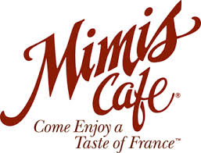
Recipe by Mimi’s Café
On our first trip to Mimi’s Café I didn’t know which muffin to choose so the waiter suggested that I try this one and it is my favorite. I hope that you enjoy it as much as I do. The original recipe can be found on their website.
Buttermilk is used in a lot of recipes. Some examples are cakes, muffins, pancakes, breads, and biscuits. I t is thick, tangy, buttery in flavor, but low in fat.
Serving size is 9-12 muffins
Ingredients: Equipment:
½ cup of sugar 6 cupcake liners
¼ cup of butter 1 mixing bowl
1 large egg electric mixer
1 ¼ cups of flour rubber scraper
1 teaspoon of baking soda muffin tin
½ teaspoon nutmeg large scoop
¼ teaspoon cinnamon oven mitts
½ cup of buttermilk dish towel/ cloth

Instructions:
Preheat oven to 375 degrees. In a mixing bowl, cream the sugar and the butter together with an electric mixer. When they are thoroughly mixed, add the egg and beat one more minute.
Sift the flour into a separate bowl, together with the baking soda, nutmeg, and cinnamon.
Add the flour and the buttermilk to the first mixture, mix at low speed until smooth. To avoid lumps in the batter, add the wet and dry ingredients alternately, in small amounts.
Place cupcake liners in muffin pan. Fill liner to ¾ full of batter and then add topping.
Bake at 375 for 20 minutes until golden brown. A toothpick inserted into the middle should come out dry
Let cool and enjoy.

